Sri Lanka Institute of Information

Technology



Lab Submission

Lab sheet 07

**IT24104301**

**Karannagoda K.V.R.**

**Probability and Statistics | IT2120**

B.Sc. (Hons) in Information Technology

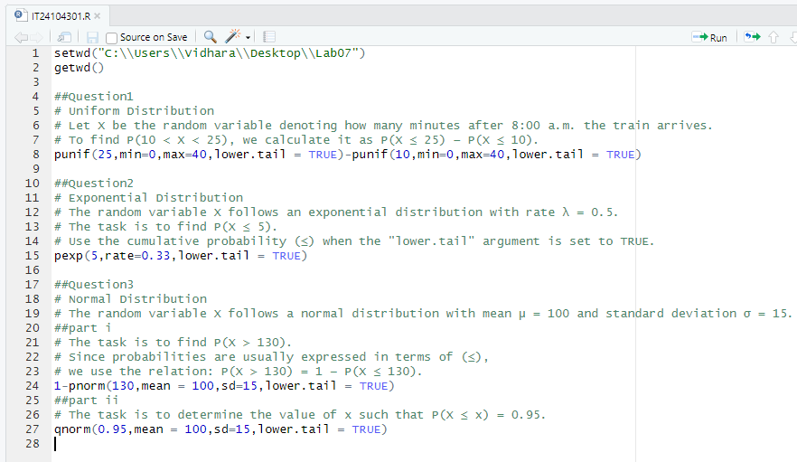**Exercise**

